KINDLY SPONSORED BY
CONCEPT TAVERNS / THE NORTHERN SNOOKER CENTRE

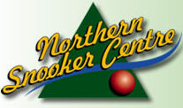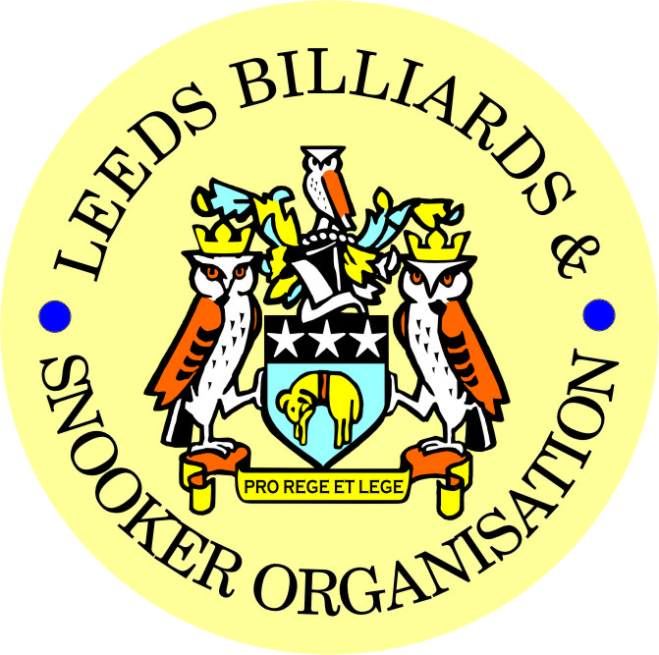

FINAL – 2021/22 LEEDS CITY SNOOKER CHAMPIONSHIP
& PRIZE PRESENTATION EVENING

FRIDAY 15th JULY 2022
NORTHERN SNOOKER CENTRE

2021/22 LEEDS CITY SNOOKER CHAMPIONSHIPS
SINGLES FINAL - BEST OF 7 FRAMES

RICHARD BINNS (0) v SCOTT RAPER (4)

FOLLOWED BY-
- PRESENTATION OF THE SINGLES TROPHY & INDIVIDUAL AWARDS-
- PRESENTATION OF OTHER 2021/22 LEEDS CITY CHAMPIONSHIPS – Annual trophies and individual awards – (see below)-

** 2021/22 LEEDS CITY CHAMPIONSHIPS **
JUNIORS - UNDER 16’s SNOOKER:
Presented by ADT Flexibles (UK) Ltd.
WINNER: VLADISLAV GRADINARI | RUNNER-UP: JAMES PEARS
SEMI-FINAL: DILRAJ RYATT | SEMI-FINAL: DANIEL BOYES
JUNIORS - UNDER 18’s SNOOKER:
“The Keith Weston Memorial Trophy”- Presented by ADT Flexibles (UK) Ltd.
WINNER: SAMUEL LEE STEVENS | RUNNER-UP: JAMES PEARS
SEMI-FINAL: JONNY COLLIER | SEMI-FINAL: OLIVER HUDSON
JUNIOR HIGH BREAK: - “The Paul Hunter Memorial Trophy” – V. GRADINARI (48)

INDIVIDUAL SNOOKER:
WINNER: SCOTT RAPER | RUNNER-UP: RICHARD BINNS
SEMI-FINAL: DAVID GRAHAM | SEMI-FINAL: MALCOLM BILCLOUGH
PAIRS SNOOKER:
Trophy - Presented by ADT Flexibles (UK) Ltd.
WINNERS: R. BINNS / G. CASSIDY | RUNNERS-UP: B. FRANKLAND / L.THEWLIS
SEMI-FINAL: R WALTON / T DOHERTY | SEMI-FINAL: M. GAUGHAN / R. PAMMENT
TEAM SNOOKER – “The Jim Fowler’s Trophy”:
WINNERS: HORSFORTH CONS ‘A’ | RUNNERS-UP: GILDERSOME CONS

2021 / 2022 - *PRIZE PRESENTATION EVENING*

WEDNESDAY 7th SEPTEMBER 2022

EAST END PARK WMC

SNOOKER - “Veterans Trophy” – 50+  “The Rodney Sims Memorial Trophy”  Presented by the LBSO | REFEREES:  Officiated in 2021-22 LBSO Competitions:
WINNER: MALCOLM TIMBLIN | MARK KING
RUNNER-UP: WINSTON DAVID | ANDY KITSON
 | NATALIA GRADINARI
 | KENNY SYMONS
PLATE WINNER: STEWART QUINN | MICHAEL DAVENPORT
PLATE RUNNER-UP: MARK McGREAVY | M BALL / M JENSON / B PATTERSON

** LBSO - SNOOKER LEAGUES **

Div: | CUP TITLE / WINNERS: | RUNNERS-UP:
Div A | The Yorkshire Evening News Shield:  NORTHERN S. C. ‘A’ | EXCELSIOR S. C. ‘B’
Div B | The Clan Tartan Trophy:  MAIN LINE SOCIAL ‘A’ | TINSHILL & COOKRIDGE ‘B’
Div C | The John Dunning Trophy:  GILDERSOME CONS ‘A’ | BRAMLEY WMC ‘B’
Div D | The J. H. Lunn Cup:  BRAMLEY WMC ‘C’ | HORSFORTH CONS ‘A’
Div E | The Peter Nelson Trophy:  HAREHILLS LIBERALS ‘A’ | HAREHILLS LABOUR ‘B’
Div F | The Peter Hawkyard Memorial Trophy:  PUDSEY LIBERALS ‘B’ | LEEDS ANGLERS ‘B’
Div G | The J. McDonnell / J. Williamson Trophy:  CROSSAGTES REC HALL ‘C’ | ROWLAND ROAD ‘D’

“CHAMPION of CHAMPIONS”  “The Jim Williamson Memorial Trophy”  Presented by the Northern Snooker Centre | WINNERS: GILDERSOME CONS ‘A’  (DIVISION C WINNERS)

LBSO - LEAGUE & COMPETITIONS – SNOOKER HIGHEST BREAKS
HIGHEST BREAK TROPHY
Presented by ADT Flexibles (UK) Ltd. in 2019

Break | League / Competition | Player (Team)
136 + 113 | LEAGUE / DIVISION G | GYLES BEHBOOD (MENSTONE S. C. ‘A’)
131 | LEAGUE / DIVISION A | JOHNATHAN BAGLEY (EAST END PARK ‘B’)
114 | STAN BROOKE SINGLES | RICHARD BINNS (BELLE ISLE WMC)
112 | STAN BROOKE PAIRS (FINAL) | LIAM PULLEN (NORTHERN SNOOKER CENTRE)
106 | LEEDS CITY SINGLES | LIAM THEWLIS (HORSFORTH CONS)
100 | LEEDS CITY TEAM | SCOTT RAPER (HORSFORTH CONS)
96 | STAN BROOKE SINGLES | JAMES PEARS (BARNBOW SOCIAL)
92 | STAN BROOKE SINGLES | MARK BALL (HORSFORTH CONS)

LEN LEE INVITATION SNOOKER – (Scratch):  “THE LEN LEE TROPHY”  Trophy presented by  ADT Flexibles (UK) Ltd  for 2020 | WINNER: RICHARD BINNS (BELLE ISLE WMC)  RUNNER-UP: ISA ISHTIAQ (EXCELSIOR S.C.)

SNOOKER – SYKES CUP - Individual Handicap.
The “GEORGE SYKES CUP”

WINNER: LEE BROOKES  (GARFORTH WMC) | RUNNER-UP: STEVEN HIRST  (BELLE ISLE WMC)
SEMI-FINAL: MALCOLM TIMBLIN  (BELLE ISLE WMC) | SEMI FINAL: JAMES PEARS  (BARNBOW SOCIAL)

SNOOKER – LEN LEE PAIRS - Pairs Handicap.
The “LEN LEE CUP”

WINNERS: K. MANN & D. WAITE  (HAREHILLS LABOUR) | RUNNERS-UP: DAVE BOYES & DANIEL BOYES  (NORTHER SNOOKER CENTRE)
SEMI-FINAL-M. SUNDERLAND / M. WILLIAMS  (BRUNTCLIFFE WMC) | SEMI-FINAL: A. KERFOOT / C. FREEMAN  (BRAMLEY WMC)

SNOOKER - 3 MAN TEAM KNOCK OUT – Handicap.
The “Leeds & District Billiards League Snooker Cup”

WINNERS: MAIN LINE SOCIAL ‘A’ | RUNNERS-UP- U& LOWER WORTLEY LIBS ‘B’
SEMI-FINAL: NORTHERN S.C. ‘A’ | SEMI FINAL: BEECHWOOD WMC ‘A’

** STAN BROOKE MEMORIAL COMPETITIONS **
(AGGREGATE SCORES – 3/4 FRAMES)

INDIVIDUAL SNOOKER – 3 FRAMES:

WINNER: JAMES PEARS  (BARNBOW SOCIAL) | RUNNER-UP: CONNOR O’CARROLL  (HAREHILLS LIBERALS)
SEMI-FINAL: MALCOLM TIMBLIN  (BELLE ISLE WMC) | SEMI FINAL: JOE MOORE  (ROWLAND ROAD WMC)
PAIRS SNOOKER – 3 FRAMES:

WINNERS: A. MASSEY & L. PULLEN  (NORTHERN SC) | RUNNER-UPGARY STEAD & GERRY WALTON  (DENISON HALL CLUB)
SEMI-FINAL: T. DOHERTY & J. DOHERTY  (DENISON HALL CLUB) | SEMI-FINAL: N. DANIELS & A. DRUMMOND  (NORTHERN S. C.)
TEAM SNOOKER – 4 FRAMES:

WINNERS: MAIN LINE SOCIAL ‘A’ | RUNNERS-UP: PUDSEY LIBERALS ‘B’
SEMI-FINAL: BELLE ISLE WMC ‘B’ | SEMI-FINAL: MORLEY CONSERVATIVES ‘A’

The “WINDSOR TROPHY” – 4 Man Team Handicap
Presented by ADT Flexibles (UK) Ltd.

WINNERS: MIDDLETON CONSERVATIVES | RUNNERS-UP: HAREHILLS LABOUR CLUB
SEMI-FINAL: NORTHERN S.C. | SEMI FINAL: TINSHILL & COOKRIDGE

CONGRATULATIONS!
TO ALL PRIZE WINNERS FOR 2021-22

The LBSO would like to thank-:

- Concept Taverns / the Northern Snooker Centre for staging the final of the 2021/22 Leeds City Snooker Singles Championship and the 1st presentation of all 2021/22 Leeds City Champions
on 15th July this year,
and also
- East End Park WMC for staging tonight’s 2nd presentation of awards for the 2021/22 season.

Presented By-

CURRENT LBSO COMMITTEE MEMBERS
PRESIDENT – CHRIS WILLIAMSON
CHAIRMAN – ANDY TAFFINDER
VICE CHAIRMAN –
LEAGUE SECRETARY – PAUL GRIMES
COMPETITION SECRETARIES – MARK BALL & PAUL MARLOW
GENERAL SECRETARY / TREASURER – BOB PATTERSON

A DATE FOR YOUR DIARY:
**14th SEPTEMBER 2022**
START OF THE 2022/23 LEAGUE SEASON

Kindly Sponsored by the
CONCEPT TAVERNS / ‘NORTHERN SNOOKER CENTRE’

